
SRM Institute of Science and Technology
Mode of Exam
OFFLINE
College of Engineering and Technology
School of Computing
DEPARTMENT OF NETWORKING AND COMMUNICATIONS
SRM Nagar, Kattankulathur – 603203, Chengalpattu District, Tamilnadu
Academic Year: 2022_2023_EVEN
Test: CLAT- 1 Date: 16/02/2023
Course Code & Title:18CSE382T_Forensics and Incident Response Duration: 60 minutes
Year & Sem: III /VI
SET : B Max. Marks: 25

Course Articulation Matrix:
Course Outcomes (CO): |  |  |  |  |  | The learners will be able to:
CO-1 : |  | Acquire the knowledge on basics of procedures for identification, preservation of electronic evidence
Program Outcomes (PO)
1 | 2 | 3 | 4 | 5 | 6 |  | 7 | 8 | 9 | 10 | 11 | 12 | PSO
Engineering Knowledge | Problem Analysis | Design & Development | Analysis, Design, Research | Modern Tool Usage | Society & Culture |  | Environment & Sustainability | Ethics | Individual & Team Work | Communication | Project Mgt. & Finance | Life Long Learning | PSO - 1 |  | PSO - 2 | PSO – 3
3
3-High, 2- Medium, 1-low

Part – A
(10 x 1 = 10 Marks)
Instructions: Answer all
Q. No | Question | Marks | BL | CO | PO | PI Code
1 | PsLoggedOn tools extract  - All the users connected locally and remotely.  - Users Connected Locally  - Users Connected Remotely  - Users who are not connected physically | 1 | 2 | 1 | 1 | 1.6.1
2 | Identify the tool used to create a secure communication channel between the devices for file transfer.  - Netcat  - Cryptocat  - Securecat  - MDcat | 1 | 1 | 1 | 1 | 2.6.2
3 | Cite the security algorithm will be mostly used to check the integrity of the document in the response toolkit  - Block SHA  - MD5  - CryptHash  - SHA 551 | 1 | 2 | 1 | 1 | 2.5.3
4 | Choose the method which is used to access the Audit log records from the System?  - gpedit-enabler  - getit-enabler  - getpedit – enabler  - getped – enabler | 1 | 1 | 1 | 1 | 1.6.1
5 | Volatile data during the incidence is a part of  - Host Based Data Collection  - Network Based Data Collection  - Analysis Based Data Collection  - IDS Based Data Collection | 1 | 2 | 1 | 1 | 1.6.1
Part – B
( 2 x 4 = 8 Marks)
Instructions: Attend all the Questions
6 | Explain the steps involved in pre-incident preparation | 4 | 2 | 1 | 1 | 2.5.1
7 | How can somebody working in a company know what to do when he/she discovers a security breach? | 4 | 3 | 1 | 1 | 2.6.3
Part – B
( 1 x 12 = 12 Marks)
Instructions: Attend all the Questions
8 | a) Discuss in detail about creating a windows response toolkit? (8)  b) Summarise the basic steps of the forensic investigation process. (4) | 12 | 2 | 1 | 1 | 2.6.2
*Performance Indicators are available separately for Computer Science and Engineering in AICTE examination reforms policy.
Course Outcome (CO) and Bloom’s level (BL) Coverage in Questions

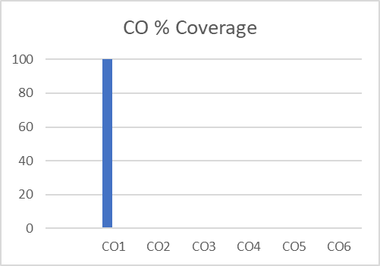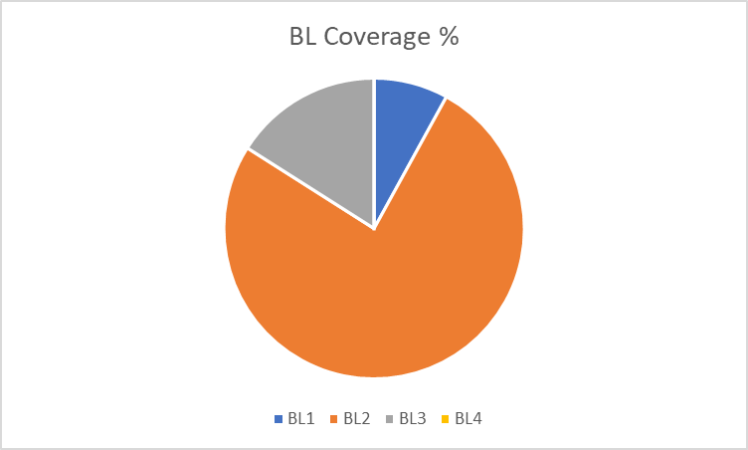

Approved by the Audit Professor/Course Coordinator

